Sliding window maximum sum of subarray of size k
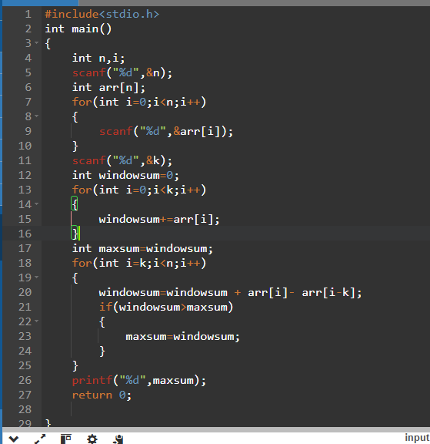
2.Minimum sum of subarray just change symbol.
3. average : average = maxsum/4
4.count of subarrays of size k with sum =x
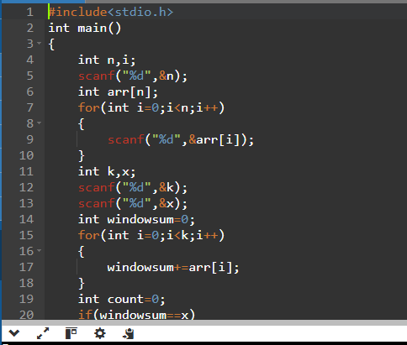

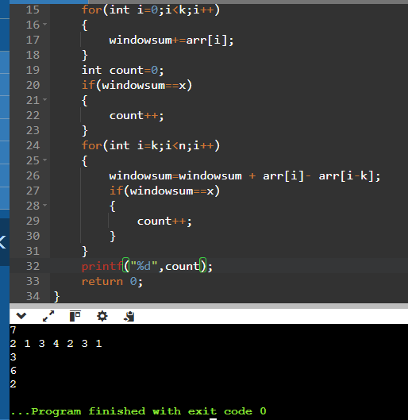
5.
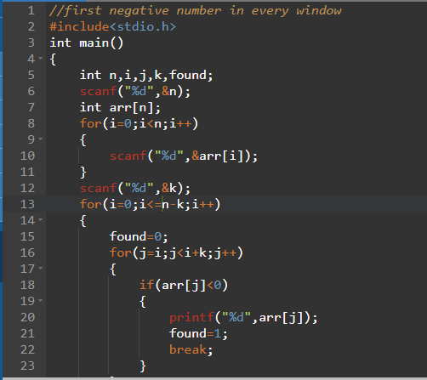
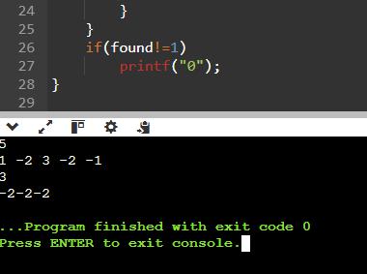

6.maximum element in every window of size k
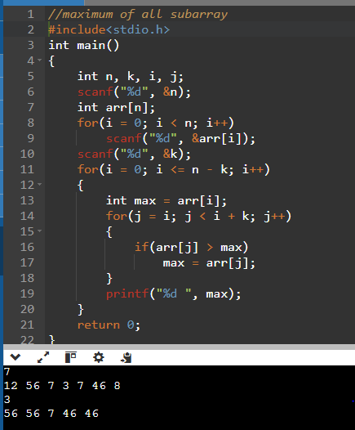
Just change symbol for minimum in line 16
7 sum of all subarrays of size k
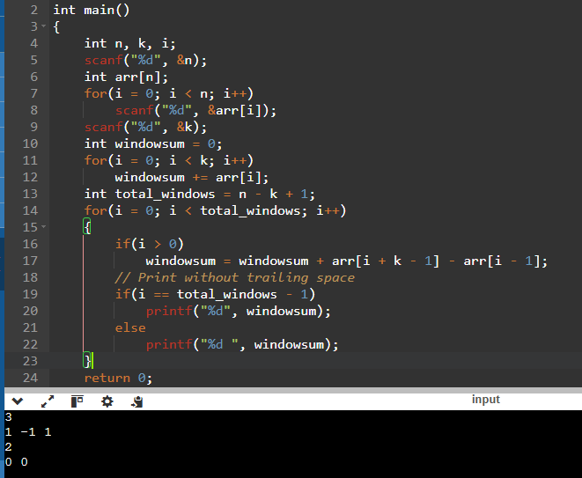
8. count even numbers in every window of size k
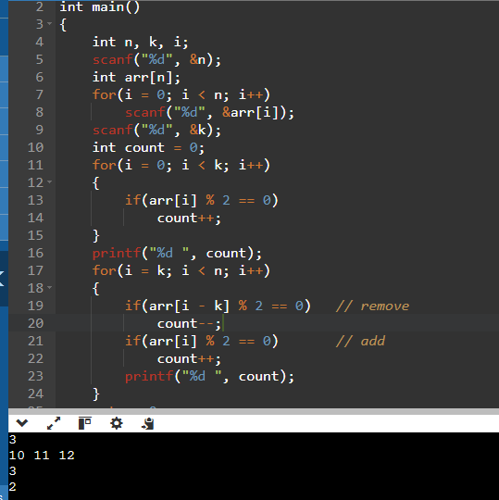
9. find the maximum sum where the windown contains only positive number
#include<stdio.h>
int main()
{
int n, k, i;
scanf("%d", &n);
int arr[n];
for(i = 0; i < n; i++)
scanf("%d", &arr[i]);
scanf("%d", &k);
int windowsum = 0;
int positiveCount = 0;
for(i = 0; i < k; i++)
{
windowsum += arr[i];
if(arr[i] > 0)
positiveCount++;
}
int maxsum = 0;
if(positiveCount == k)
maxsum = windowsum;
// Slide the window
for(i = k; i < n; i++)
{
// remove outgoing element
windowsum -= arr[i - k];
if(arr[i - k] > 0)
positiveCount--;
// add incoming element
windowsum += arr[i];
if(arr[i] > 0)
positiveCount++;
// check if all are positive
if(positiveCount == k && windowsum > maxsum)
maxsum = windowsum;
}
printf("%d", maxsum);
return 0;
}
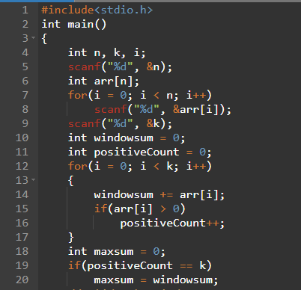
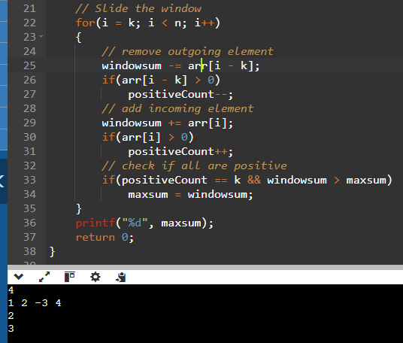
10.count of windows with all distinct elements with size k
#include<stdio.h>
int main()
{
int n, k, i;
scanf("%d", &n);
int arr[n];
for(i = 0; i < n; i++)
scanf("%d", &arr[i]);
scanf("%d", &k);
int count = 0;
// Loop through all windows
for(i = 0; i <= n - k; i++)
{
int isUnique = 1;
// Check uniqueness inside the window
for(int j = i; j < i + k; j++)
{
for(int l = j + 1; l < i + k; l++)
{
if(arr[j] == arr[l])
{
isUnique = 0;
break;
}
}
if(!isUnique)
break;
}
if(isUnique)
count++;
}
printf("%d", count);
return 0;
}

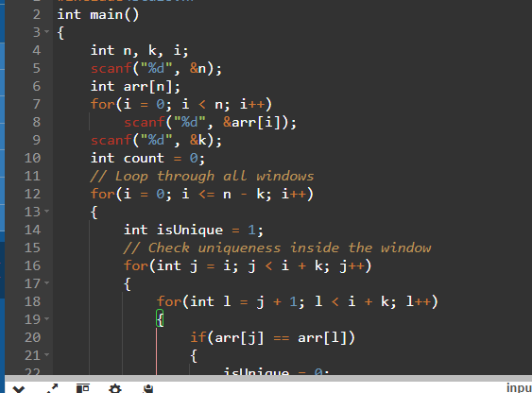
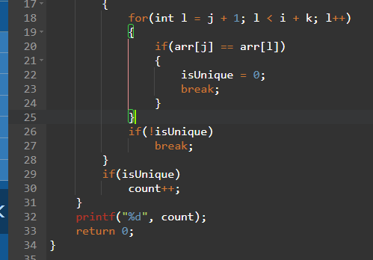
Multiplication
